

Recruitment Pack

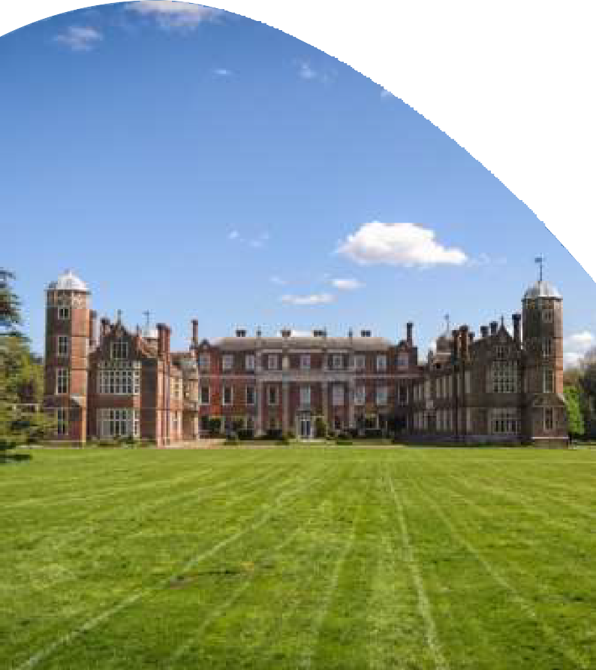

Visiting Teacher of Low Strings

The UK's only Round Square Boarding and Day School for Girls

aged 11-18



# JOB DESCRIPTION

The following duties shall be deemed to be included in the professional duties which you may be required to perform:

* Support the aims and objectives of Cobham Hall.
* Comply with the School Foundation Health and Safety Policy.
* Planning and preparing and delivering a series of individual music lessons taking into account differing levels of ability.
* Take a role in coaching the extracurricular groups as agreed with the Head of Music, and be available, as appropriate, to attend school concerts.
* Preparing pupils for examinations as agreed with the Head of Music, assessing, recording and reporting, as required by the School, on the development, progress and attainment of pupils.
* Promoting and safeguarding the welfare of children and young persons for whom you are responsible and with whom you come into contact.
* Maintaining good order and discipline among the pupils and safeguarding their health and safety both when they are on the school premises and when they are engaged in authorised school activities elsewhere in your care.
* Communicating and cooperating with persons or bodies outside the School.
* Participating in any meetings for Health and Safety/Safeguarding, etc., run by the School.
* To carry out the above duties and responsibilities and any other additional duties as designated appropriate by the Headmistress.

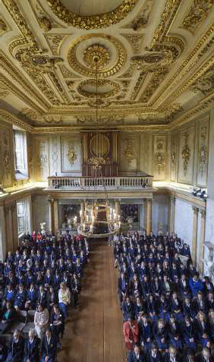

# PERSON SPECIFICATION

A background of working in education is desirable although not essential.

## ESSENTIAL QUALITIES

* High professional and personal standards
* Excellent musical knowledge and ability
* Educated to degree level in Music
* Ability to work as part of a team
* Excellent verbal and written communication skills
* Ability to communicate effectively with pupils in age groups from 11 – 18 years
* Ability to communicate effectively, and liaise with, Foundation Teaching and Support Staff
* Effective organisational skills
* Flexibility and patience in the workplace
* Ability to enthuse others

## DESIRABLE QUALITIES

* Previous experience of teaching in a school environment
* Knowledge of young people and education
* Self-motivated
* Uses his/ her initiative
* Advanced (beyond undergraduate) training and performance qualifications
* Knowledge of current GCSE and A-Level performance requirements
* Professional experience as a performer





# Key facts about Cobham Hall School

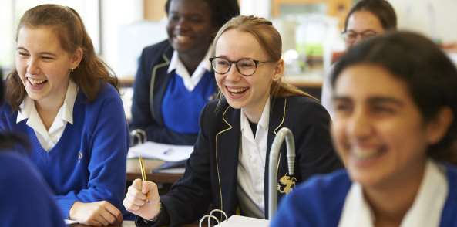

The School also oﬀers:

* Contributory Pension Scheme.
* Comprehensive induction and on-going opportunities for Professional Development.
* Use of the School ﬁtness room, tennis courts and swimming pool.
* Free onsite parking.
* Lunches and refreshments provided.
* Access to 150 acres of Grade II* designed parkland.

# CLOSING DATE FOR APPLICATIONS

## WEDNESDAY, 24th AUGUST 2022.

*The School is an equal opportunities employer. We are committed to safeguarding and promoting the welfare of children and young people and expect all staﬀ and volunteers to share this commitment. Successful applicants are subject to a DBS check.*

*“Pupils are educated to a high standard and excel in extra-curricular activities fulﬁlling the school’s aim to develop each pupil’s potential in and out of the classroom.”*

- ISI Report-

# INFORMATION ABOUT COBHAM HALL

Cobham Hall is housed in a beautiful Grade 1 listed Tudor mansion built in 1584 and was at one stage home to the Ashes of cricketing folklore. The School is otherwise set in 150 acres of tranquil 18th Century park landscape in the pretty village of Cobham in Kent.

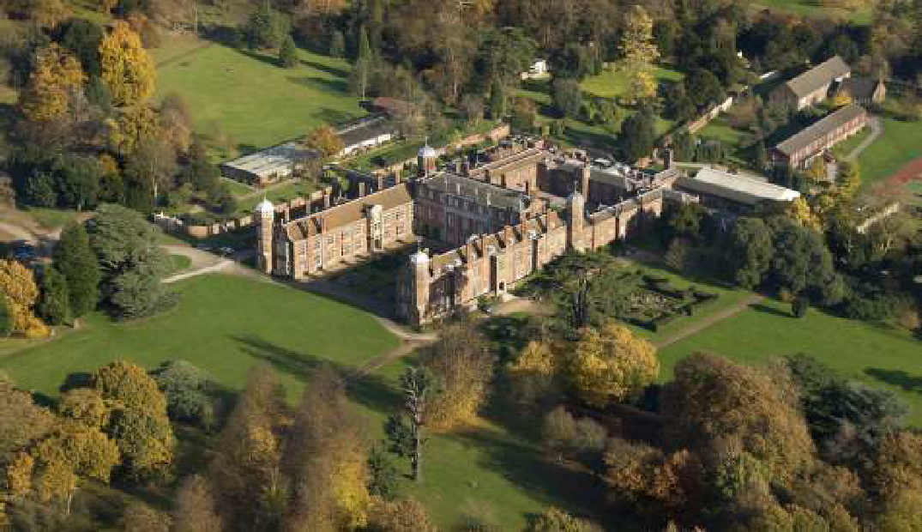

The School is within half an hour of central London via the High Speed train service from Ebbsﬂeet International to London St Pancras and within an hour of the Channel ports of Dover and Folkestone by car.

Cobham Hall was founded in 1962 and is a single sex Boarding and Day school for girls aged 11 to

18. It is a member of the Round Square network of schools and indeed when it became a member back in 1971 was, at the time, the ﬁrst all-girls’ school to join the network.

The Round Square IDEALS are central to the School’s ethos, helping each student to realise that “there is more in you than you think”: the School’s moto. There is a high commitment to the personal wellbeing of each student and Cobham Hall is recognised as a leading innovator in this area.

Our small class sizes ensure that each student is supported on their educational journey and enables lessons to be dynamic and engaging.

Our Headmistress, Mrs Wendy Barrett, took up this role in 2020 having previously held the post

of Deputy Headmistress. Under her guidance, the School has developed an ambitious strategy to drive up standards and ensure that our students leave with the academic and character skills necessary to adapt to, and thrive in, an ever changing World.

In March 2021, Cobham Hall merged with the Mill Hill School Foundation, a merger that has opened up new opportunities for investment and collaboration. The School is currently consulting parents on the introduction of boys into the Sixth Form.

Full details of Cobham Hall’s most recent inspections are available on our website at [www.](http://www/) cobhamhall.com. In summary, a full integrated ISI inspection in 2015 found the majority of areas looked at to be excellent, with the remainder

all found to be good, whilst in 2019 the School received an incredibly positive report from CReSTeD.

For further details about Cobham Hall please refer to the School’s website. The School is an equal opportunities employer. We are committed to safeguarding and promoting the welfare of children and young people and expect all staﬀ and volunteers to share this commitment. Successful applicants are subject to a DBS check.



There is more in you than you think

Cobham, Kent DA12 3BL, United Kingdom Tel: +44 (0)1474 823371









[vacancies@cobhamhall.com](mailto:vacancies@cobhamhall.com) [www.cobhamhall.com](http://www.cobhamhall.com/)

Follow us @CobhamHall

  